Literacy:  Writing:Writing a Portal Story with a focus on openings and endings.  Reading: We will be improving our comprehension skills by answering questions on vocabulary, summarising, inferring, predicting and explaining our answers with evidence from the text.  Class novel: Ma’at’s Feather by Juliette Desailly  Spelling: - ough suffix, silent letter spellings, - ible and - able suffixes, homophones, personalised spelling lists. | Maths:  In maths we will be learning about the decimal fractions in our number system -tenths, hundredths and thousandths. We will learn their place value and then learn to add, subtract and round them.  We will also be using money to solve problems.  Please keep practising your time tables! | Science:  Forces:  Using knowledge and understanding of gravity, air resistance, friction, mechanisms that require force, to investigate and problem solve.
Home Learning: Please aim to hear your child read daily and be sure to ask questions to challenge their understanding.  Spelling and maths homework will be set once a week (set and to be handed in on Wednesdays). The children should also be using Times Table Rock stars and Spelling Shed at home. Please let us know if accessing ICT at home is an issue. | 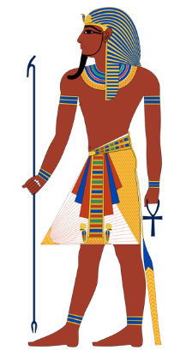  Year 5 – Autumn 1  Topic: Pharaohs | RE:  We will be reading and examining the various viewpoints around how the world began. We will be looking at the creation story from Genesis alongside the scientific explanations for the creation of the earth. The big question we will consider throughout our learning is: Science and Religion are they contradictory or complementary?
Other subjects:  PE:Our PE days are Monday and Friday. Please ensure children have a full PE kit in school on these days.  PSHE/RHE: We will focus on our school value ‘endurance’ - making links throughout our topic. Our maths lessons will also include growth mind-set activities to start the year.  French: We will be practising the days of the week and months of the year. Linking French vocabulary to our topic work and learning some simple greetings. | School Values  We will be working on our endurance to keep going at new things and situations that we find tricky. We will be focussing on the value of compassion and forgiveness as we learn about how to develop and build our friendships and relationships with people in our families and in the wider community. We will increase our wisdom as we reflect on our learning and make links with knowledge that we already have. We will be hopeful for a happy year in our school community where we can all learn and shine. | Topic: Pharaohs  History: The Ancient Egyptians – the Egyptians.  Art: Drawing artefacts, headwear, hieroglyphics, amulets  Geography: Human and physical features of Egypt (tourism, The River Nile.)  DT: Clay water carriers and pulley systems and cooking.  Music: African drumming.  EXPRESS EVENT: Egyptian Day – 19/10/22

