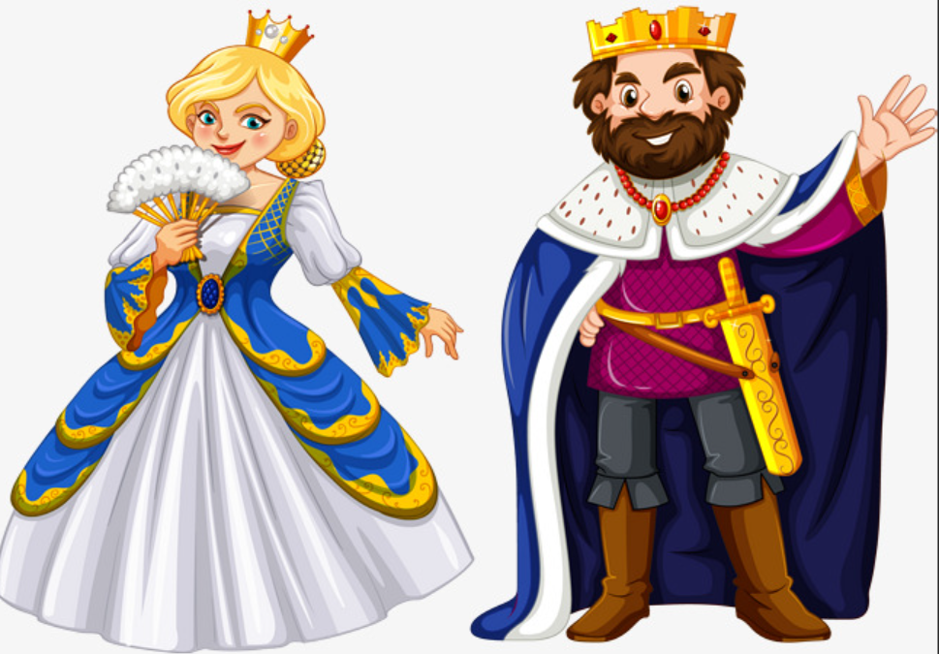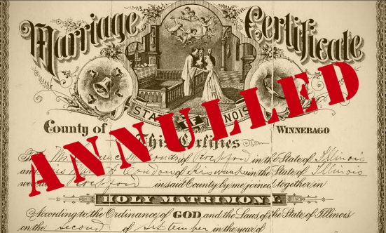

miniature

annulment

reign

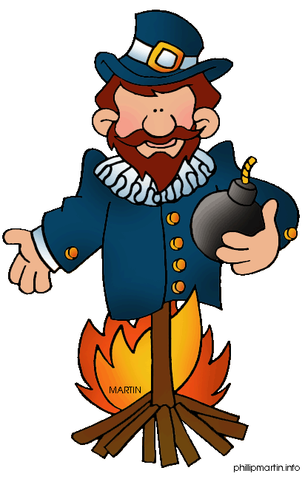

punishment

treason

Word

Wheel

Against sovereign (King or Queen) or country.

**1066**

execution

portrait

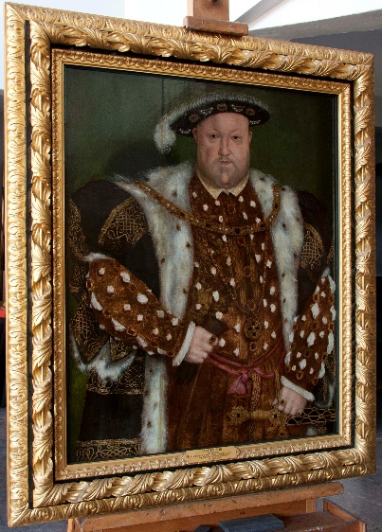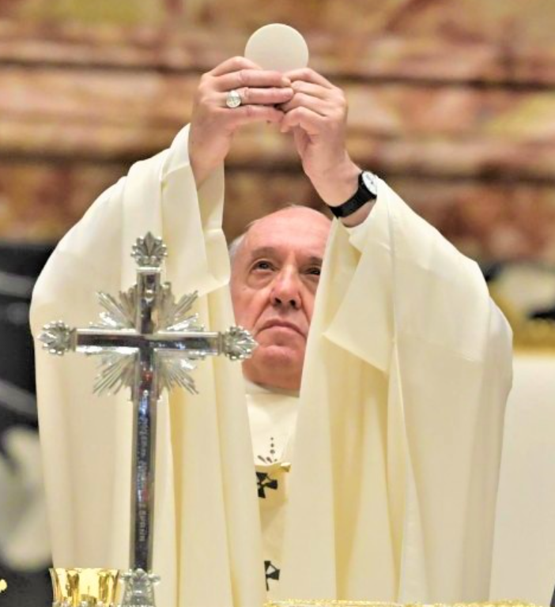

Catholic

reformation

Protestant