Literacy:  Writing: This term we will start our writing by exploring a non-fiction explanation text and writing our own text. Then we will return to our Tales of Fear, revisiting our learning from the Autumn term and looking in more detail at adding description for impact and engagement.  Reading: We will be looking at a range of explanation texts to support our non-fiction writing unit. We will also be reading our class text – 1066 – I Was There.  Spelling: This term we will be starting a new spelling scheme called Read, Write Inc. Each week we will focus on a new spelling rule. The rule, and words that fit this rule will be given for homework. | Maths:  Multiplicative Reasoning: Learning the short written method for division and reasoning and problem solving using this method.  Area and scaling: Finding areas of rectangles and rectilinear shapes and solving problems involving scaling. | Science:  Materials and their properties:  We will be scientifically investigating this topic in a number of ways including- -Comparing and grouping together everyday materials on the basis of their properties. -know that some materials will dissolve in liquid to form a solution and describe how to recover a substance from a solution. -Investigating how materials can be separated by filtering, sieving and evaporating. -Giving reasons, for the particular uses of everyday materials, including metals, wood and plastic. -Investigating how changes to materials can be reversible or irreversible.
RE:  In RE this term, we will be finding out about the Hindu religion. We will think about what Hindus believe about their Gods, how they worship and where they worship. The River Ganges will be the focus of our learning and we will be reflecting on the question: Would it feel different to visit the River Ganges as a Hindu? | 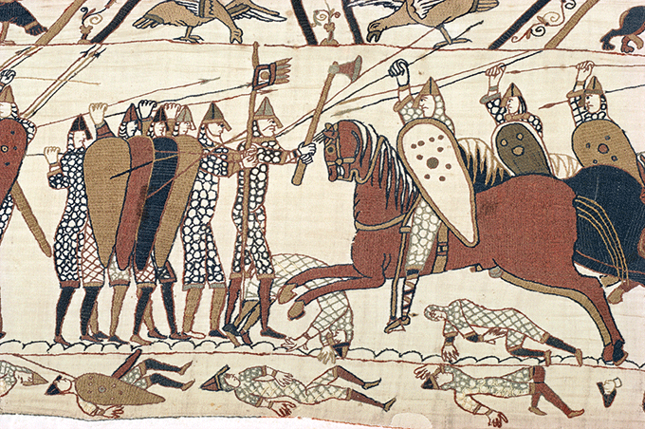  Spring 1  Topic: 1066  Year 5 | Computing:  To use presentation software and skills to present work or information relating to their learning.  PE:  Our indoor PE sessions are on a Monday afternoon. This term we will be focussing on fitness.  Outdoor PE will be on a Friday afternoon. This term we will learn skills associated to the game of netball.
RHE:  Our topic this term is ‘Too Much Selfie Isn’t Healthy.’ The lessons will cover: how we care for and are thinking of others and the different ways we can show love for one another.  ARTS – Music, drama, art and DT  We will cover aspects of our topic through these subjects including embroidery in the style of the Bayeux Tapestry. | School Values:  As we explore our topic, we will also be thinking about our school values of endurance, compassion, forgiveness, wisdom and hope and making links to the ways in which these values were shown throughout, medieval period despite the fact that it was an uncertain and volatile historical era.  Home Learning: Weekly homework will continue to be set every Wednesday. Topic homework is set at the beginning of each term and should be completed in time for the end of the half term. | Topic: 1066  History and Geography focussed: The Normans – who were they, where did they come from, what did they want, how did they live, what impact did they have on England?  - The Bayeux Tapestry  - The Domesday Book  - The Battle of Hastings and William the Conqueror.

