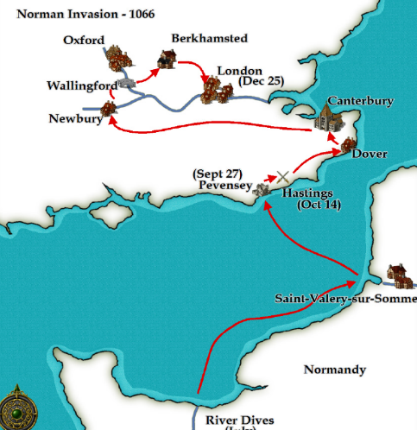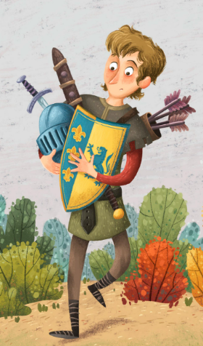

invasion

Past tense

fought

squire



defeat

conflict

Word

Wheel

**1066**

retreat

allies

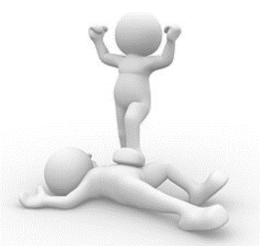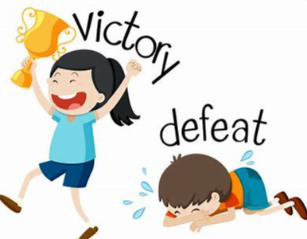

conquer

victory

architecture