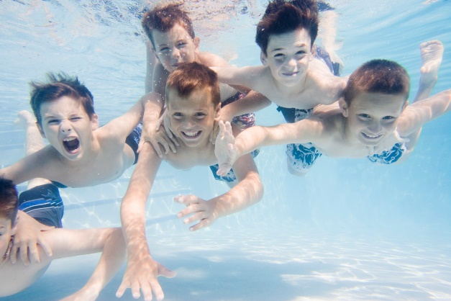
ST MARY’S PRIMARY SCHOOL
YEAR 4 - SWIMMING LETTER

Dear Parents/Carers,

Year 4 children will be swimming this term – their lessons will be 1pm – 1:30pm on Thursdays.

Lessons will be starting on Thursday 15th September 2022 up to and including – Thursday 8th December 2022 for 12 sessions – this excludes 27th October 2022 due to half term.

The cost is £4.50 per lesson x 12 weeks = £54.00
A discount has been applied to those children who qualify for free school meals and will show on ‘My child at school’ when you pay.

This is a significant saving on swimming lessons through school as currently lessons at the leisure centre are £7.46 per lesson and class sizes up to 10.

Please sign and return the consent form for the term and return to the school office as soon as possible. We ask that you pay online using the my child at school login details here under school trips https://www.mychildatschool.com. If you do not have these details or have forgotten them, please ask the school office to assist.

In order to pay the Leisure Centre and Swimming Teachers it has been decided that termly payments (where possible) are much easier for parents and staff as often children have forgotten to hand in their money and we have to chase it up.

Children must bring swimming costumes and towels in the morning. Girls or boys with long hair will need to have it tied back for the lesson, many thanks.

Kate Batorska
Head teacher

SWIMMING FOR YEAR 4 – Thursday 15th September 2022 up to and including – Thursday 8th December 2022

I wish ____________________________________ to go swimming and

- *I have paid £54.00 via my child at school system
Or
- *I will pay £4.50 weekly via my child at school system (delete which is not applicable)

Signed ________________________________________________Parent/Carer

