Use of TEAMS

In addition to the rules below (included in the original permission letter):
- Do not email other children unless given permission to by a member of staff
- Be respectful to others and do not send any inappropriate messages
- Do not subscribe to any social media sites or website mailings list using your school email address
We would like to add the following:
- You must not set up your own groups on teams and invite children from the class
- The chat function should only be used when a teacher is online to share feedback about work and assignments set. When a teacher is online to share feedback, you can then use the chat function to catch up with friends.
- Video calls to friends on Teams are not permitted
- You must not invite people to chat with you using teams
The Teams platform is monitored by the class teachers and it is also checked by the ICT technicians at Colfox, who inform us of any misuse of the system. If there are incidents of any kind related to Teams, we will contact parents and children to discuss the matter further using our E-Safety policy to guide us (a copy of which can be found on the school website).
-It is really important that children remember to follow the internet safety rules at all times when using any internet platform:
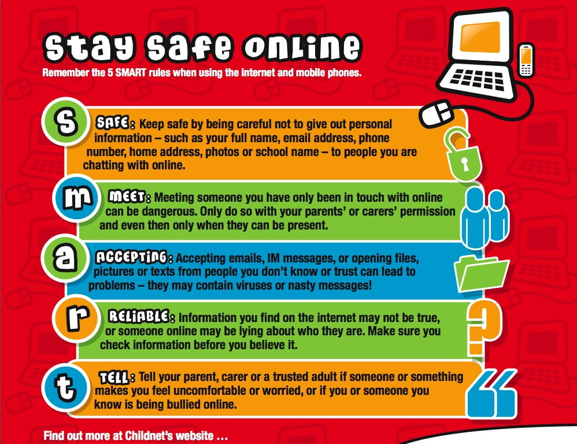
We will be resending the permission slip to include these new additions. Please sign and return to your child’s class teacher.
Many Thanks,
Sarah-Jayne Samuel
E-Safety Champion

Dear Parents/Carers,
Microsoft Office 365 for Years 5 and 6 at St Mary’s Primary School
After discussions with the Sir John Colfox Academy, we have made the decision to issue all children in years 5 and 6 at St Mary’s their own school email address which will enable them to access Microsoft Office 365. This email account will be provided for educational use only. We ask that it is not used as a personal email account and that the following rules are adhered to:
- Do not email other children unless given permission to by a member of staff
- Be respectful to others and do not send any inappropriate messages
- Do not subscribe to any social media sites or website mailings list using your school email address
- You must not set up your own groups on teams and invite children from the class
- The chat function should only be used when a teacher is online to share feedback about work and assignments set. When a teacher is online to share feedback, you can then use the chat function to catch up with friends.
- Video calls to friends on Teams are not permitted
- You must not invite people to chat with you using teams

All emails sent through our system will be monitored and misuse will be dealt with in accordance with our school policies. We ask that you discuss this with your child to ensure that they are aware of this.
Along with their school email address, you and your children will be able to access all the features of Office 365. With Office 365, your child will now have access to the latest version of Word, Excel, PowerPoint, OneNote and much more.
You will be able to:

- Install on up to 5 compatible PCs and Macs, plus 5 tablets (including iPad!)
- Use with OneDrive for automatic device syncing
- Gain valuable skills on the world’s most popular productivity software!
Your child’s Office subscription lasts for as long as they are on roll here and the program continues to be supported by Microsoft.
Your child will need their email address and password (attached to this letter) in order to sign on. All school email addresses use the domain name @stmarybridport.dorset.sch.uk. To install Microsoft Office onto a compatible PC/Mac you must log into the Office 365, click on Install Office (top right hand corner) and follow the instructions to download the software. If you have trouble installing Office, this guide may resolve your issue: http://aka.ms/office365help.
The availability and compatibility of this software is determined by Microsoft and St Mary’s can take no role or responsibility in supporting these installations. Please also note that this software is only available to you whilst your child is at St Mary’s, children will have their license removed when they leave.
We seek your consent for your child to use the above stated Office 365 Education online services. To enable your child to sign-on and access these services, Microsoft require access to your child’s username, first and last name, year level and school.
If you have any questions about your child having an email address or any queries about Office 365, please email in the office@stmarybridport.dorset.sch.uk and we will respond to your query.
Please complete the attached consent form and return to the school office by Friday 7th October .
Many thanks,
Kate Batorska
School Email Address and Access to Office 365
Please complete the attached consent form and return to the school office by Friday 7th October.
Name of child:_________________________________­­­­_____________________________________­­­­­­­­­­­­­­­­­­­­­
I give permission for my child to have a school email address to enable them to use Office 365. I understand that my child must only use it for schoolwork in accordance with the rules outlined above □ (tick)
Name (Parent/Carer):________________________________________________________________
Signed (Parent/Carer):_______________________________________________________________
Date:____________________________________

