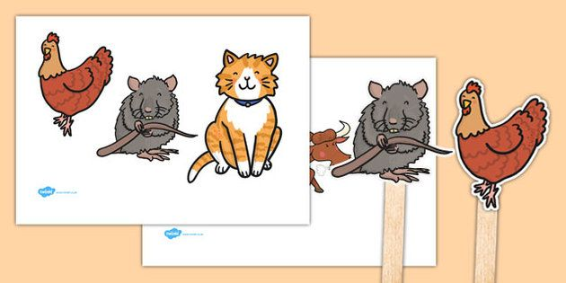
little red hen
bull
rat
cat

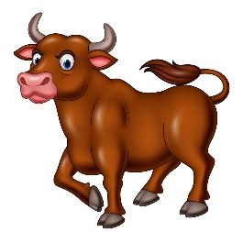
I
“Not I”
Little Red Hen
Spring 1

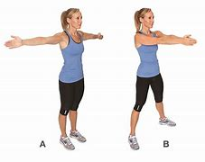

“Who”
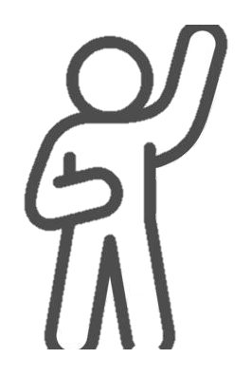
“Oh very well I’ll do it myself and so she did”

