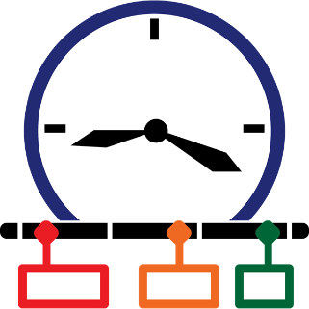
Season
Winter
Spring
Summer
Autumn
Timeline
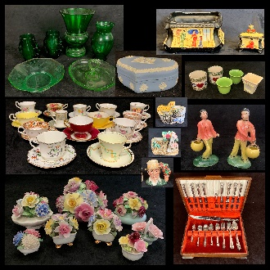
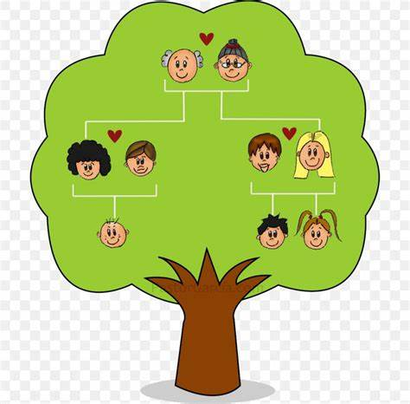
Artefact
Family tree
first / next / then
Long Long Ago
Spring 1

