Literacy  This term we will be writing an information piece of writing and see if we can try and inform and teach other people. We will be Looking at information text about giants then writing our own.  This term we will be focussing on stories. We will look at description and making sure we have adjectives. Whilst also making sure we have all the punctuation we need such as capital letters, full stops and finger spaces. | Maths  In Maths this term we will be looking at different aspects in Maths. We will be spending time learning to count backwards in ones, twos, 5s and 10s. We will be concentrating on Maths vocabulary such as addend, sum, minuend, subtrahend and difference when working out addition and subtraction questions.  We will be learning about position and direction. We will also be learning about time as well. | Science  In science this term we are learning about our human body. As part of science and PSHCE lessons.  Computing  In our computing lessons, we will be learning about researching online. We will look at particularly the different sites and attractions in London. We will then be making a presentation all about London and what we have learnt.
PSHE  In PSHE this term we will be looking carefully at our bodies and looking after them.  PE  This term PE will be on a Monday and Thursday afternoon. Please ensure that your child brings their full kit to each session.  On Thursday’s the children will be learning about athletics and learning some cricket skills.  During our Tuesday lessons we are continuing to work through the Real PE syllabus. | 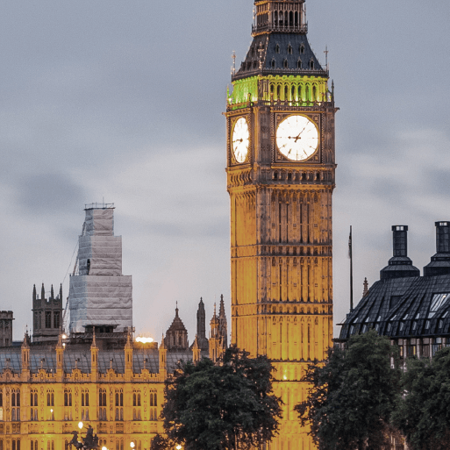  Year 1’s topic this term is… Bright Lights Big City. | RE  This term we will be learning about Judaism. We will be learning about the festival of Chanukah and thinking about why it is important to Jews.  Humanities  In geography this term we will be learning about human and physical features of the United kingdom and contrasting them with other countries. We will also be comparing London and Kuala Lumpar.  In history we will be learning about the Great Fire of London. We will look at what started the fire and why it is so significant in history.
Arts – Art, Music, D&T  In music we will be continuing learning how to play the ocarina. The year 1s will be headlining OcStock music festival this year. We will also be learning the National anthem.  In D&T this half term we will be making our own models of famous London landmarks, using constructions kits and then junk modelling.  We will then look at how we can build our own taxi using wheels, rods and axels. | Values  Forgiveness – We look for acts of forgiveness  Compassion –. We will continue to be mindful of the feelings of others and the impact of our actions. We will consider the opinions of Jews and the importance of Chanukah to them.  Wisdom – We will be developing our knowledge and understanding of key events in our world and local history, including the great fire of London and learning about our queen.  Hope & Endurance – We will be looking for hope to the future as we start thinking about moving on to the next year group. | Reminders  For our D&T projects this term please could you child collect any junk modelling materials they may be able to bring in for us to make the London landmarks.  Please continue to read with your child every day and note your initials in their yellow reading record. If you can state when your child has finished we can ensure that your child is promptly given a new reading book.

